**Assignment 3**

**Problem Statement**

**1. What are the names of all the countries in the databases which start with the letter "B"**

**(sorted by their names)?**

**The SQL query used:**

**select country from country where country like 'B%' order by country;**

**Output:**

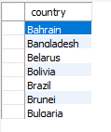

**Screenshot:**

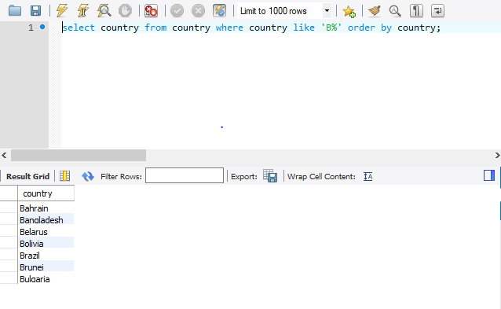

**2. Return the first names (sorted) of all the actors with the last name "berry".**

**The SQL query used:**

**select first_name from actor where last_name ='berry' order by first_name;**

**Output:**

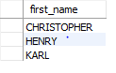

**Screenshot:**

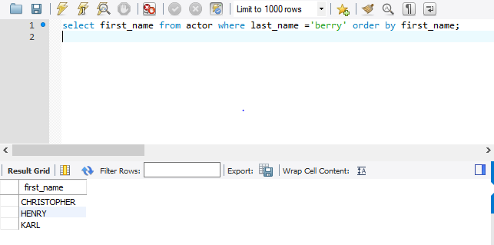

**3. Find all the films whose length is more than 184 (inclusive). Order the results by the length**

**(and for films with the same length order them by their name). Return their title and the length.**

**The SQL query used:**

**select title, length from film where length>=184 order by length, title;**

**Output:**

|  |  |
| --- | --- |
| title | length |
| CONSPIRACY SPIRIT | 184 |
| CRYSTAL BREAKING | 184 |
| KING EVOLUTION | 184 |
| MOONWALKER FOOL | 184 |
| SMOOCHY CONTROL | 184 |
| SONS INTERVIEW | 184 |
| SORORITY QUEEN | 184 |
| THEORY MERMAID | 184 |
| CHICAGO NORTH | 185 |
| CONTROL ANTHEM | 185 |
| DARN FORRESTER | 185 |
| GANGS PRIDE | 185 |
| HOME PITY | 185 |
| MUSCLE BRIGHT | 185 |
| POND SEATTLE | 185 |
| SOLDIERS EVOLUTION | 185 |
| SWEET BROTHERHOOD | 185 |
| WORST BANGER | 185 |

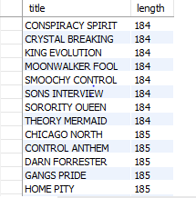

**Screenshot:**

